Advanced SQL Exercises for Online Retail Store
Exercise 1: Ranking and Window Functions Goal: Use ROW_NUMBER(), RANK(), DENSE_RANK(), OVER(), and PARTITION BY. Scenario:
Find the top 3 most expensive products in each category using different ranking functions.
Steps:
1. Use ROW_NUMBER() to assign a unique rank within each category.
2. Use RANK() and DENSE_RANK() to compare how ties are handled.
3. Use PARTITION BY Category and ORDER BY Price DESC.
CREATE DATABASE ProductDB;
GO

USE ProductDB;
GO

CREATE TABLE Products
(
ProductID INT PRIMARY KEY,
ProductName VARCHAR(50),
Category VARCHAR(30),
Price DECIMAL(10,2)
);

INSERT INTO Products VALUES
(101,'Laptop','Electronics',80000),
(102,'Mobile','Electronics',50000),
(103,'Tablet','Electronics',50000),
(104,'Headphones','Electronics',3000),

(105,'Shirt','Clothing',2000),
(106,'Jeans','Clothing',3000),
(107,'Jacket','Clothing',3000),
(108,'T-Shirt','Clothing',1500),

(109,'Novel','Books',600),
(110,'Dictionary','Books',900),
(111,'Comics','Books',900),
(112,'Magazine','Books',400);
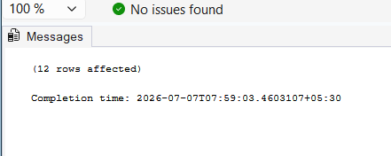

USE ProductDB;

SELECT
ProductID,
ProductName,
Category,
Price,
ROW_NUMBER() OVER
(
PARTITION BY Category
ORDER BY Price DESC
) AS Row_Number
FROM Products;
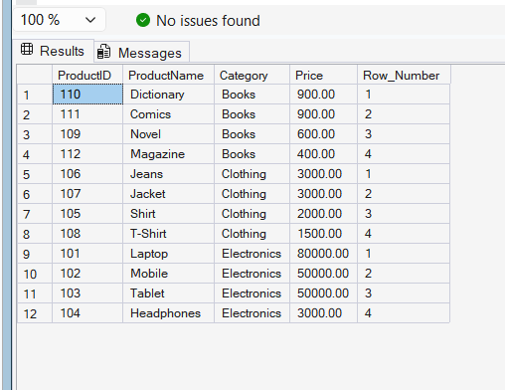
USE ProductDB;

SELECT
ProductID,
ProductName,
Category,
Price,
RANK() OVER
(
PARTITION BY Category
ORDER BY Price DESC
) AS Rank_No
FROM Products;
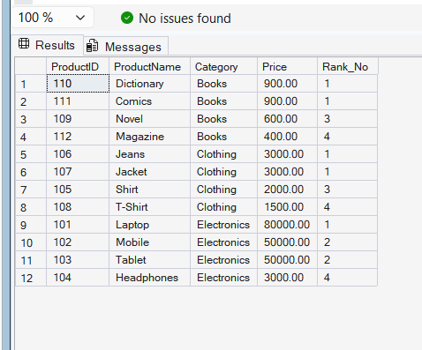
USE ProductDB;

SELECT *
FROM
(
SELECT
ProductID,
ProductName,
Category,
Price,
ROW_NUMBER() OVER
(
PARTITION BY Category
ORDER BY Price DESC
) AS Row_Number
FROM Products
) AS RankedProducts
WHERE Row_Number <= 3;
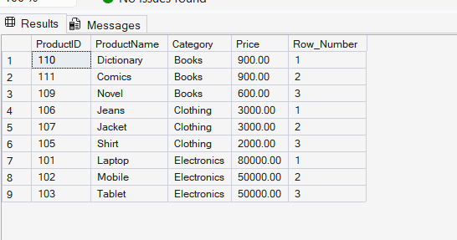

4. SQL Exercise - Stored procedure
Exercise 1: Create a Stored Procedure
CREATE DATABASE EmployeeManagementDB;
GO

USE EmployeeManagementDB;
GO
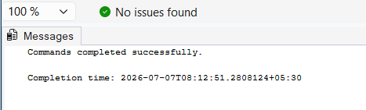
CREATE TABLE Departments
(
DepartmentID INT PRIMARY KEY,
DepartmentName VARCHAR(100)
);
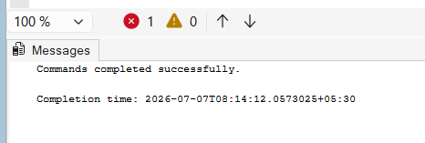
CREATE TABLE Employees
(
EmployeeID INT IDENTITY(1,1) PRIMARY KEY,
FirstName VARCHAR(50),
LastName VARCHAR(50),
DepartmentID INT,
Salary DECIMAL(10,2),
JoinDate DATE,
FOREIGN KEY (DepartmentID) REFERENCES Departments(DepartmentID)
);
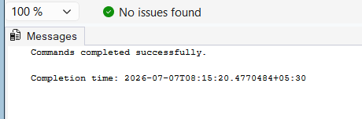
INSERT INTO Departments (DepartmentID, DepartmentName)
VALUES
(1,'HR'),
(2,'Finance'),
(3,'IT'),
(4,'Marketing');
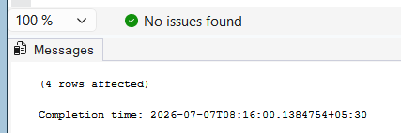
INSERT INTO Employees
(FirstName, LastName, DepartmentID, Salary, JoinDate)
VALUES
('John','Doe',1,5000,'2020-01-15'),
('Jane','Smith',2,6000,'2019-03-22'),
('Michael','Johnson',3,7000,'2018-07-30'),
('Emily','Davis',4,5500,'2021-11-05');
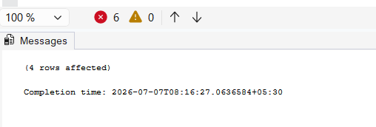
SELECT * FROM Departments;

SELECT * FROM Employees;
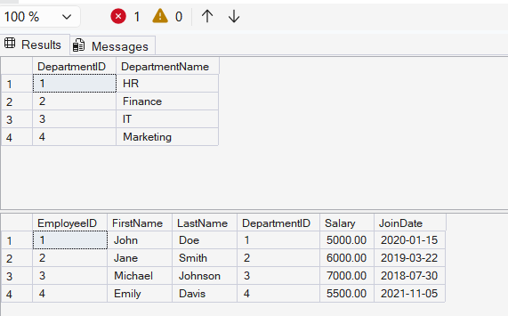
CREATE PROCEDURE sp_GetEmployeesByDepartment
@DepartmentID INT
AS
BEGIN
SELECT *
FROM Employees
WHERE DepartmentID = @DepartmentID;
END;
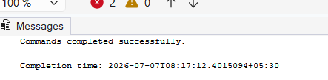
EXEC sp_GetEmployeesByDepartment @DepartmentID = 3;
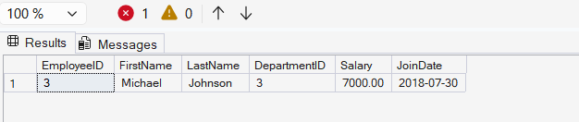
CREATE PROCEDURE sp_InsertEmployee
@FirstName VARCHAR(50),
@LastName VARCHAR(50),
@DepartmentID INT,
@Salary DECIMAL(10,2),
@JoinDate DATE
AS
BEGIN
INSERT INTO Employees
(FirstName, LastName, DepartmentID, Salary, JoinDate)
VALUES
(@FirstName, @LastName, @DepartmentID, @Salary, @JoinDate);
END;
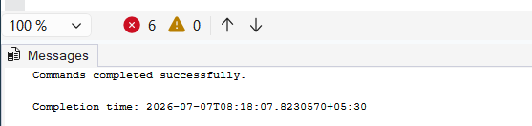
EXEC sp_InsertEmployee
@FirstName = 'Akshitha',
@LastName = 'Naga',
@DepartmentID = 3,
@Salary = 6500,
@JoinDate = '2024-06-01';
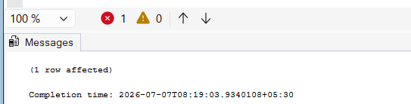
SELECT * FROM Employees;
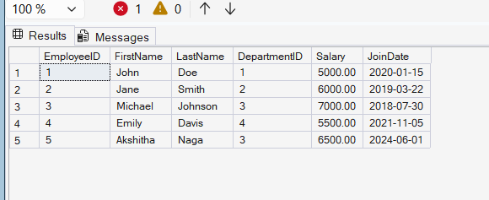

Exercise 5: Return Data from a Stored Procedure
USE EmployeeManagementDB;
GO
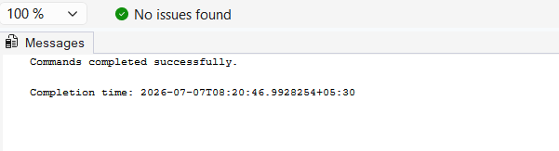
CREATE PROCEDURE sp_GetEmployeeCountByDepartment
@DepartmentID INT
AS
BEGIN
SELECT COUNT(*) AS TotalEmployees
FROM Employees
WHERE DepartmentID = @DepartmentID;
END;
GO

EXEC sp_GetEmployeeCountByDepartment @DepartmentID = 3;
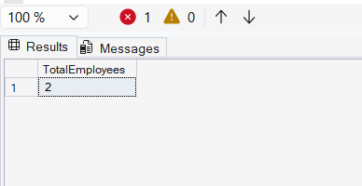
EXEC sp_GetEmployeeCountByDepartment @DepartmentID = 1;
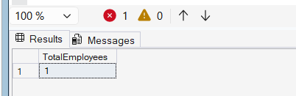
EXEC sp_GetEmployeeCountByDepartment @DepartmentID = 4;
